

Mark: /32

YEAR 12 PHYSICS

PRACTICAL ASSESSMENT

CIRCULAR MOTION

NAME: ______________________________

Time allowed: 55 mins

A talented physics student conducted an experiment investigating circular motion. The conical pendulum apparatus is shown below. Inspect the diagram & labels carefully.

The stopper was whirled in a circle and the radius of the circle was kept at a constant value of
0.600 m.

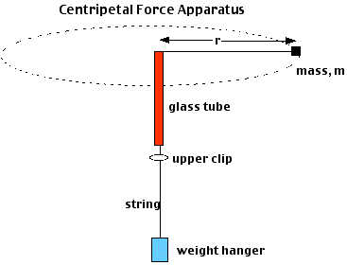
Mass supplying the centripetal force (F_{c})
stopper (mass = m)
alligator clip or sticky tape

The results obtained are shown on the table on the next page:

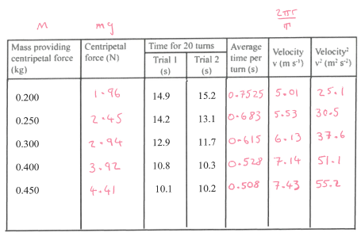

0.200 14.9 15.2

0.250 14.2 13.1

0.300 12.9 11.7

0.400 10.8 10.3

0.450 10.1 10.2

- Complete the table of results above. (4 marks)
1 mark per correct column, 3 s.f. is acceptable.

- The experiment contained design elements to improve the following:

- Accuracy (ensuring the measured value is close to the true value),
- Precision (reducing variability among individual measurements), and
- Reliability (ensuring repeatability of results under identical circumstances).
- Validity (ensuring that the experiment is measuring what it is intended to measure by controlling appropriate variables).

Detail one way each of the above were addressed in this experiment:

Accuracy (any 1 of the following):  By performing more rotations, the experiment aimed to reduce the impact of potential systematic errors or uncertainties, contributing to improved accuracy by enhancing the likelihood that the measured value is close to the true value.  Multiple trials allow for the identification and potential mitigation of systematic errors, outliers or anomalous results, supporting improved accuracy. | Precision (any 1 of the following):  Averaging measurements over 20 rotations reduces the influence of random errors and measurement uncertainties, contributing to improved precision. Variability among individual measurements is minimized, leading to a more precise estimate of the period of the pendulum.  Conducting 2 trials provides an opportunity to assess the variability among individual measurements, contributing to improved precision. Identifying and addressing outliers helps reduce variability and enhances the overall precision of the results.
Validity (any 1 of the following):  Controlling relevant variables (length of string, mass of stopper, number of rotations per trial) ensures that the experiment is focused on the specific relationship between the variables of interest.  Conducting multiple trials ensures that the observed patterns are not due to chance or isolated incidents, enhancing the overall validity of the experiment. | Reliability (any 1 of the following):  Performing multiple rotations in each trial enhances the reliability of the measurements as random errors average out. Repeatability under identical circumstances is improved.  Running multiple trials assesses the consistency and repeatability of the results, enhancing reliability by allowing outliers or unexpected variations to be identified.  Control over relevant variables (length of string, mass of stopper, number of rotations per trial) enhances the reliability of the results by ensuring repeatability under consistent conditions.
*Teacher judgement may be used to award marks to any other acceptable response. (4 marks)

- On the graph paper provided, plot the data of centripetal force versus velocity squared. Include a line of best fit. (5 marks)
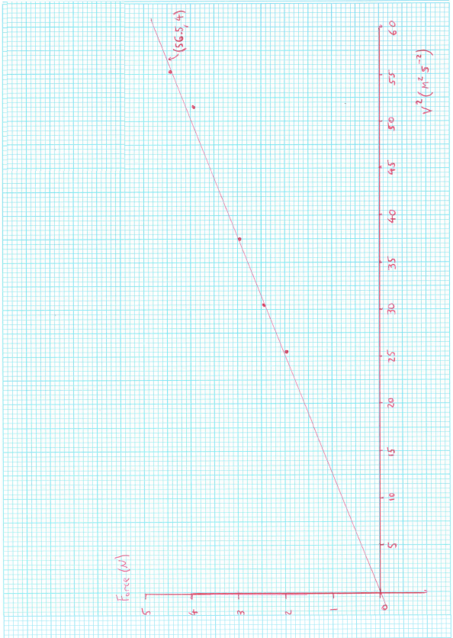
AxisLabels with units (2 marks), Appropriate Scale for both Axes (1 mark),
Correct Plotting (1 mark), Appropriate LOBF (1 mark).

- Use the graph from Q3 to determine the mass of the rubber stopper (show all working below and clearly explain any data taken from the graph or table): (4 marks)

$$Slope= \frac{y_{2}-y_{1}}{x_{2}-x_{1}}=\frac{4-0}{56.5-0}=0.0708 \left(accept 0.0650-0.0750\right) (1 mark)$$

$$Slope= \frac{Rise}{Run}=\frac{F_{C}}{v^{2}} (1 mark for stating this relationship)$$

$$F_{C}=\frac{mv^{2}}{r}→\frac{F_{C}}{v^{2}}=\frac{m}{r}=Slope$$

$$∴m=r×Slope=0.600×0.0708 (1 mark for relating m \& r to slope)$$

$$m=0.0425 kg=42.5 g \left(accept 39 g-45 g\right) (1 mark)$$

*If the final result is outside of acceptable range due to calculated slope being outside of accepted range in step 1, but all subsequent calculations are correct, deduct the mark in step 1 only and award follow-through marks for complete working.

- In reality, the fishing line will not rotate in a perfectly horizontal circle.

Tension

Glass tube

Stopper

Fishing line

Weight Force

Masses

- Draw fully labeled arrows on the diagram above to represent all forces on the stopper. (2 marks)
See above (1 mark per arrow).

- What force, or component of force, balances the weight of the stopper? (1 mark)

The Horizontal Component of the Tension Force (1 mark)
- In this experiment, it was assumed that the tension in the fishing line is equal to the centripetal force. If the fishing line makes an angle to the horizontal as shown above, this will not be true. If the angle between the string and the horizontal is 5°, use simple trigonometry to show that the difference between T and Fc is still less than 1% (you should not need to calculate T and Fc numerically - include any relevant diagrams in your answer): (3 marks)

$$\cos{5°}=\frac{F_{C}}{T}→T\cos{5°}=F_{C}→F_{C}=0.996 T (1 mark)$$

$$∴F_{C}=99.6\% Magnitude of T, Difference<1\% (1 mark)$$

F_{C}
5⁰
(1 mark)
W
T

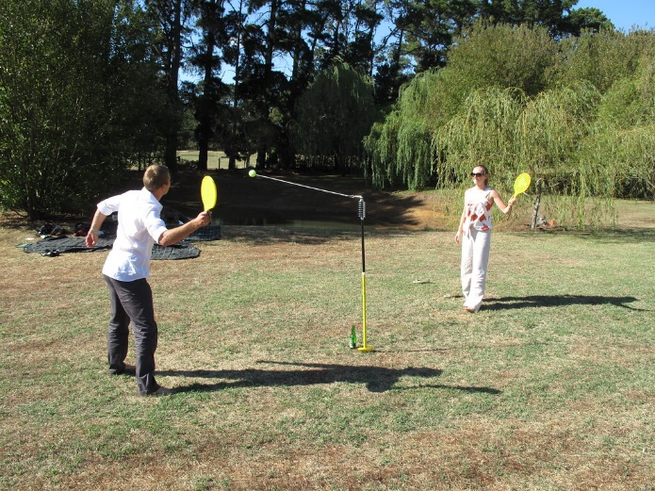
- In a real-world application of the conical pendulum: You are playing totem tennis with a friend and hit the ball so that it begins to travel in a circular horizontal path. If rope length is 1.2 meters, the ball has a speed of 3.7 m/s, a mass of 0.42 kg, and its (presumed weightless) rope makes a 49⁰ angle with the pole, find the tension force that the rope exerts on the ball. Include any relevant diagrams in your answer. (5 marks)

49⁰
T
1.2 m
49⁰

F_{C}
r

Both diagrams | (2 marks)
$$\sin{49°}=\frac{r}{1.2}→1.2\sin{49°}=r=0.906 m$$ | (1 mark)
$$F_{C}=\frac{mv^{2}}{r}=\frac{0.42×{\left(3.7\right)}^{2}}{0.906}=6.35 N$$ | (1 mark)
$$\sin{49°}=\frac{F_{C}}{T}→T=\frac{6.35}{\sin{49°}}=8.41 N$$ | (1 mark)

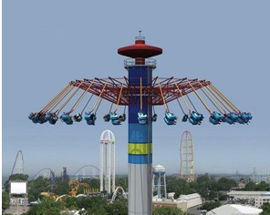
- You are at the carnival and decide to go on the swing ride. It is a high rotating platform from which the swing seats hang like pendulums. As the platform begins to turn, your swing’s chain does not stay perpendicular to the ground, but angles out from the vertical. If your distance from the center of rotation is 8.50 m, and you go around once every 12.0 sec, what angle does your swing make with the vertical? Include any relevant diagrams in your answer. (4 marks)

$$v=\frac{2πr}{τ}=\frac{2π(12)}{8.50}=8.87 m/s (1 mark)$$

θ
a_{g} = g
a_{c} = v²/r

(1 mark)

$$\tan{θ}=\frac{a_{c}}{a_{g}}=\frac{{v^{2}}/r}{g}=\frac{v^{2}}{rg}→θ=\tan^{-1}\left(\frac{{8.87}^{2}}{8.50×9.8}\right) (1 mark)$$

$$θ=43.4° (1 mark)$$

*Students may use force vectors instead of acceleration vectors. In this case, the mass terms should cancel out in the tan θ expression, resulting in the same outcome, so pay marks for this approach.

END OF VALIDATION

(Spare graphing page overleaf if required)

